Laboratory 14: Phasors
(Edit this document as needed)

Partner 1: __________Saaif Ahmed______________

Partner 2: ____________John Gonzalez_____________

Partner 3: _______________________________ (if needed)

Part A
Brief description of the Phasor RC circuit experiment:

(These questions are very similar or the same as last week. Read them carefully so you note any differences.)
When measuring the output voltage across the capacitor, what type of filter is the RC circuit? (Reference: page 4 of Experiment 7)
Low pass filter

What is the corner frequency of the circuit? (Reference: page 4 of Experiment 7)
1591Hz

Is the 10kHz input signal above or below the corner frequency?

Above
At a 10kHz source frequency, will the amplitude of the output voltage be about the same, smaller or much smaller than the amplitude of the input voltage?

Much smaller
Mathematical expression of the source voltage, including numerical values for the amplitude, the radial frequency (ω = 2πf) and the phase. (Information about the phase of a source is in the experiment writeup).

V(t)=1(cos(20000π*t))

Identify the phasor representation for your above source voltage equation.

(1 V)e^(j*20000π*t)

Verification of your calculation by the Teaching Assistant/Instructor. ____YL_________

Plot of the source voltage (input) and capacitor voltage (output) with a source frequency at the corner frequency, f_{c}, with annotations as indicated in the experiment. (LTspice)

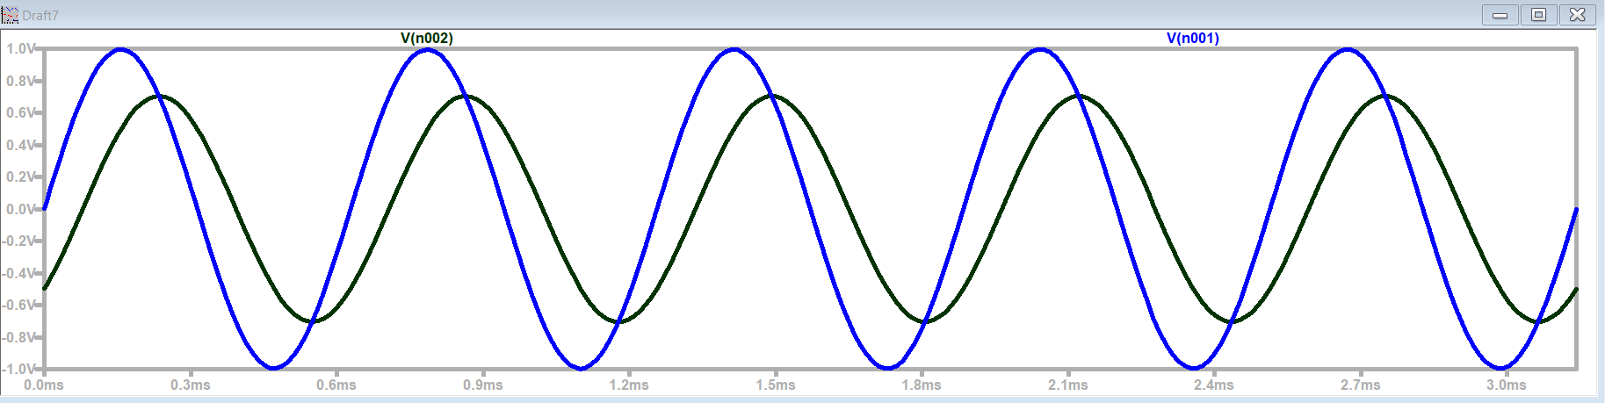
Amplitude: 0.693V
Phase: 0.13*2π

Blue: Source
Black: Cap (Output)

Plot of the source voltage (input) and capacitor voltage (output) with a source frequency at ten times the corner frequency, 10f_{c}, with annotations as indicated in the experiment. (LTspice)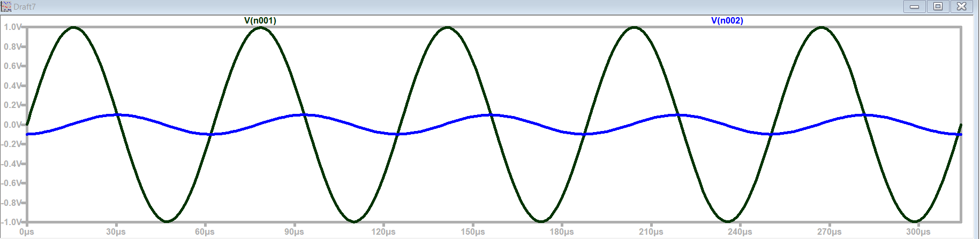
Amplitude: 0.98V
Phase: 0.23*2π

Blue: Source
Black: Cap (Output)

Plot of the source voltage (input) and capacitor voltage (output) with a source frequency at one-tenth the corner frequency, f_{c}/10, with annotations as indicated in the experiment. (LTspice)

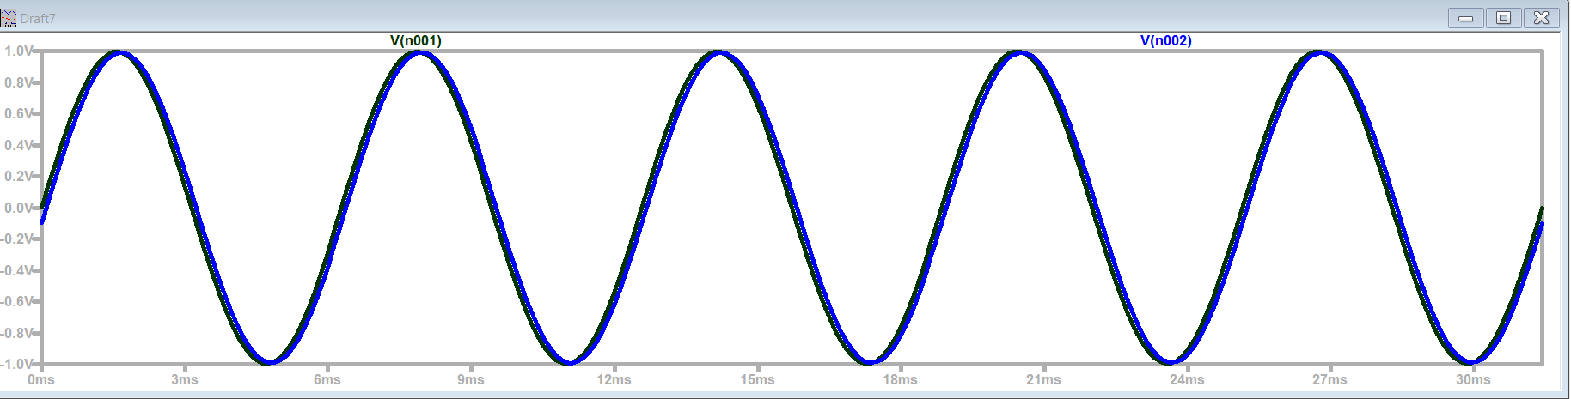
Amplitude: 1V
Phase: 0
Blue: Source
Black: Cap (Output)

What is the phase shift between the output and the input at the corner frequency?

0.13*2π

Describe the ratio of the output amplitude (magnitude) to input amplitude (magnitude) at 10f_{c}.
The ratio is 1/10 the amplitude of the source voltage

Describe the ratio of the output amplitude (magnitude) to input amplitude (magnitude) at f_{c}/10.
The ratio is essentially 1/1 to the source voltage.

Approximately, what is the phase shift between the input and the output at a frequency of 10f_{c}?
0.23*2π

Approximately, what is the phase shift between the input and the output at frequency of f_{c}/10?

0 radians.

Plot of the source voltage (input) and capacitor voltage (output) with a source frequency at the corner frequency, f_{c}, with annotations as indicated in the experiment. (Discovery Board)

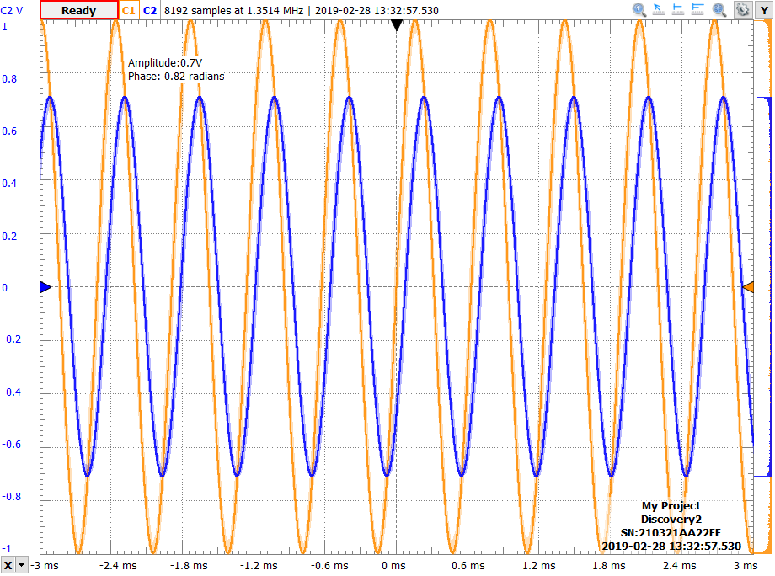

Plot of the source voltage (input) and capacitor voltage (output) with a source frequency at ten times the corner frequency, 10f_{c}, with annotations as indicated in the experiment. (Discovery Board)
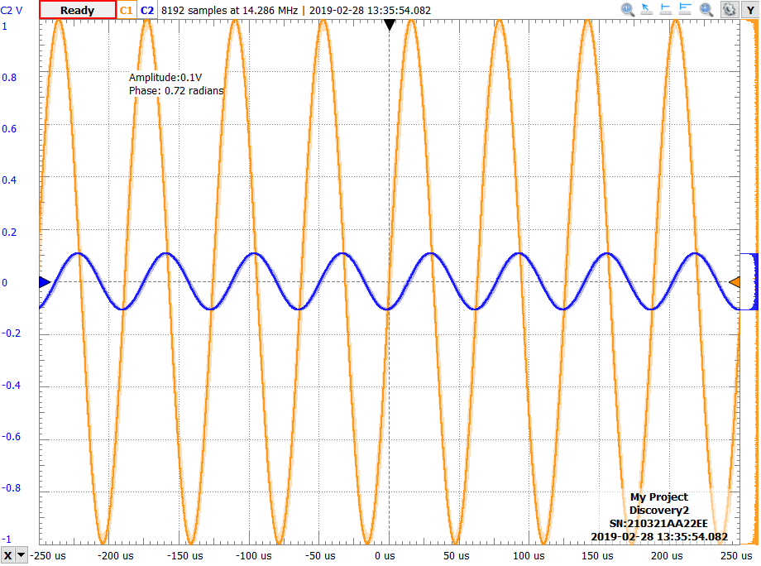

Plot of the source voltage (input) and capacitor voltage (output) with a source frequency at one-tenth the corner frequency, f_{c}/10, with annotations as indicated in the experiment. (Discovery Board)
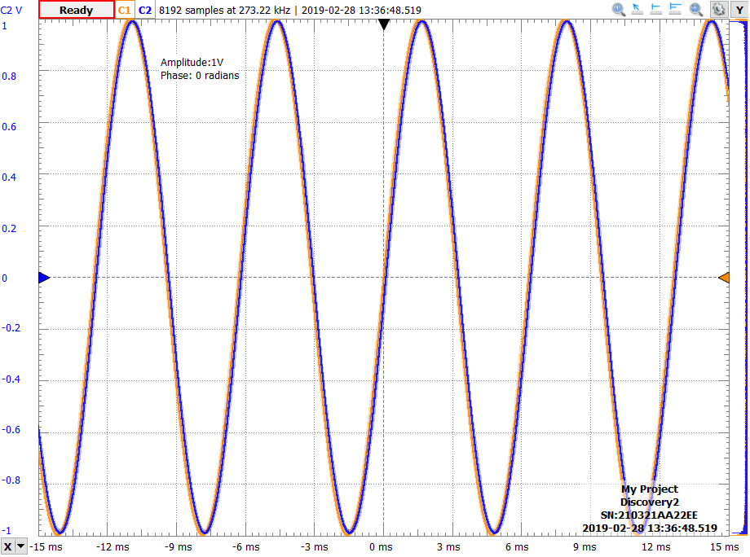

How do your experimental results and simulation results compare?

Our experimental results are within reasonable error of the theoretical results. For this experiment

Part B
Brief description of the Phasor Analysis experiment:
Determine the mathematical components of the RC circuit and develop calculations for different frequencies.

General form of the impedance of a resistor, Z_{R}.
Z_{R}=R

General form of the impedance of a capacitor, Z_{C}.
Z_{C}=1/(2π*f*C*j)

Transfer function of the RC circuit, using phasor notation.
1/(1+wcrj) = ((1+wcr)^2)*e^(-j*arctan(WCR))

Simplification of the transfer function at the corner frequency, f_{c}.

Simplification of the transfer function at 10 times the corner frequency, 10f_{c}.

Simplification of the transfer function at one-tenth the corner frequency, f_{c}/10.

Calculated magnitude and phase of the output voltage at the three frequencies being studied

Frequency | Calculated Magnitude | Calculated Phase
f_{c}
10f_{c}
f_{c}/10

For each output voltage, find the time varying form

Frequency | Output voltage, time varying form
f_{c}
10f_{c}
f_{c}/10

Measured magnitude and phase of the output voltage at the three frequencies being studied

Frequency | Measured Magnitude | Measured Phase
f_{c}
10f_{c}
f_{c}/10

Verification of your calculation by the Teaching Assistant/Instructor. _______________

Extra Credit (2 pts):
Excel plots of the experimental results and the calculated results using the time varying form, for each frequency.

